For corrections or additions, contact Anne Sorce
or Don Cooper!
President’s Letter pg 1
Editorials pg 2
Chairman of the Board pg 3
2006 Reunion Site pg 4
Honor Roll pg 5
News from the Class of ‘63 pg 6
News from the Class of ’64 pg 7
News from the Class of ‘65 pg 8
News from the Class of ‘66 pg 9
News from the Class of ‘67 pg 10
News from the Class of ‘68 pg 11
News from the Class of ‘69 pg 12
News from the Class of ‘70 pg 13
Bitburg Trip 2004 pg 14
Our Journey Home pg 15
Sonics Coming to Clinch Mountain pg 16
Bitburger Pils pg 17
Missing List pg 18

Baron Scroll Spring 2005
For those of you who may be unfamiliar with the way a lot of web material is presented in our articles, you will find that clicking a person’s name when it appears underlined in blue will cause a window to appear for sending email to that person. Other words and phrases (underlined in blue) are links that lead to related material when clicked.


President's Message

Baron Scroll
Vol. IV No. 3 Bitburg Alumni Association
Spring 2005
Greetings to our alumni “brats”. Start off this year with a New Year’s Resolution to attend the Bitburg HS Alumni Reunion being held in June 2006. Focus on this as a very important project and plan everything around it. We want to see regular faces, new faces, and old faces – please join us. Bill “Tiny” Wiehl ’67 has found the site, signed the contract and is lending his expertise to the reunion coordinators, Camille Hitch Smith ’64 and Martin “Pud” Charlton ‘69. If you live in the Atlanta area and would like to assist with the reunion, please contact Camille or “Pud”. More information about the place and dates can be found in this newsletter.

I want to thank all of you for all the support you have sent to Lorraine and me in dealing with the diagnosis of our mother’s lung cancer, which the doctors informed our family about last month. We ask for your continued prayers for her. Her name is Dora Strum and I know her faith is a vital factor. She has been very courageous throughout this crisis and has set the standard for us to follow.

Your 2005 donation can be sent to Gerry LAGISH Hilliard – she’s waiting to make those bank deposits!

Have a wonderful spring and let us hear from you!

Regards from your President,

Loretta Rhorer McAtee ‘65

Baron Scroll Spring 2005 Page 2
EMAIL ADDRESSES HELP
DEFRAY COSTS
Did you know that this past year, the BHS ROSTER was emailed to those who made monetary contributions, instead of mailing it? (For those without computers, we did print and mail a few.) This helped our account balance tremendously.
I know that many of you are inundated with emails and you hate to give your email address out to anyone other than family for fear of spamming or worse. However, you save the organization a lot of time and money if you can provide your email to our roster editor, Sue Weeks Hanson, so that she can maintain it to send out rosters. When you send her your email address you can let her know if it is okay to post it on the web, or if you want her to keep it private only for use when emailing the roster. That way when it is time to send the rosters she can easily get them to you without trying to track you down by mail or phone.
Please remember to update your email address with Sue whenever you change it, and don't forget to tell her whether you want it private or published. Thanks.
CLASS NEWS
I would like to thank the class reps who responded to my pushing, prodding and pleading and the alums who responded to my many emails. We try to make the Scroll interesting to all, but without input from ALL of the class reps this isn’t possible. You will see, as you read this edition of the Scroll, that you can tell us as much or as little as you wish. We accept photographs, links to websites, etc. If you are emailing photographs, please keep them small enough that they are manageable and open quickly. If you have questions about downsizing them, I’m sure Don Cooper can assist you. Please send your news to your class rep (see class pages) or Anne Marie Sorce.

You don’t need to wait until someone contacts you. If you have something you would like to share at this time, instead of procrastinating, please take a few minutes and send it to us now. Should something occur during the year, instead of waiting, just send the news to us, and we will publish it in the next Scroll. Do you have suggestions for improving the Scroll? Please let us know - we appreciate all feedback.
Baron Scroll Spring 2005 Page 4
Reunion Site Selected for 2006
After a year of reviewing over 100 potential hotel sites for the 2006 Reunion,
the Unicoi Lodge in the Georgia Blue Ridge Mountains, north of Atlanta has been selected.



The 100 potential sites included hotels on the Channel Islands off the coast of the Carolinas and Georgia and conference sites around the Atlanta region. After further consideration, we felt the Unicoi offered the best value and they are willing to assist us in having an exceptional reunion. In January, Patty and Pud Charlton ’69 and I visited the Unicoi Lodge to get a true taste of the facilities and the surrounding area. The Unicoi has sufficient meeting room space to accommodate our dinner and dance functions and will provide a separate meeting room for our “Teen Club” activities.

The lodge has 100 guest rooms and a dozen separate cabins about 2-3 blocks away near the lake. The guest rooms will run us $92 per night and the cabins (whether 1 bedroom, 2 bedrooms or 3 bedrooms - there are 4 each) will be $99 per night. Use this downloadable form to reserve your rooms, or call the lodge and make a reservation. Make sure you mention that you are with the Bitburg HS Reunion to receive the discounted rate.

We have been able to keep our registration fee low again this year due to the site we selected. The fee for alumni is $90 and $65 for significant other. The web site has the registration form to submit with your registration fee. It is important to register if you plan to attend, since we will need to establish a meal count within a month of the reunion.

We selected the weekend of June 9-10/11 in 2006 as the reunion weekend. Further into the summer months the room rate rises, and earlier in the year becomes difficult for a lot of people to attend. So this weekend was chosen as a compromise.

The Unicoi Lodge is about a mile outside a little Bavarian town called Helen. Helen, Georgia is nestled in the Blue Ridge Mountains on the Chattahoochee River. If you want to learn more about the town of Helen, check out their web site, www.helenga.org. You can find additional information about the Unicoi Lodge at www.unicoilodge.com.

Hope to see everyone there in 2006.
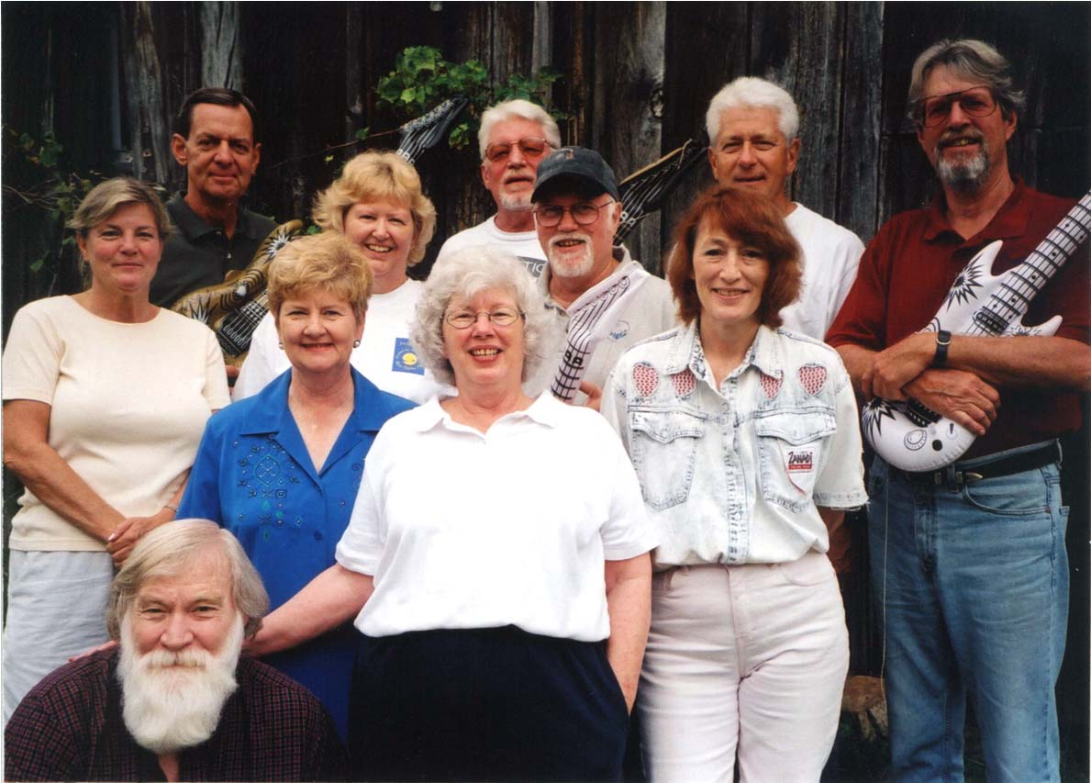
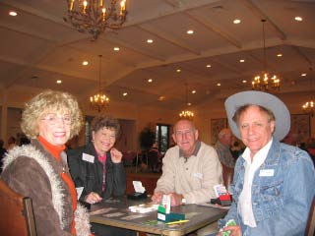
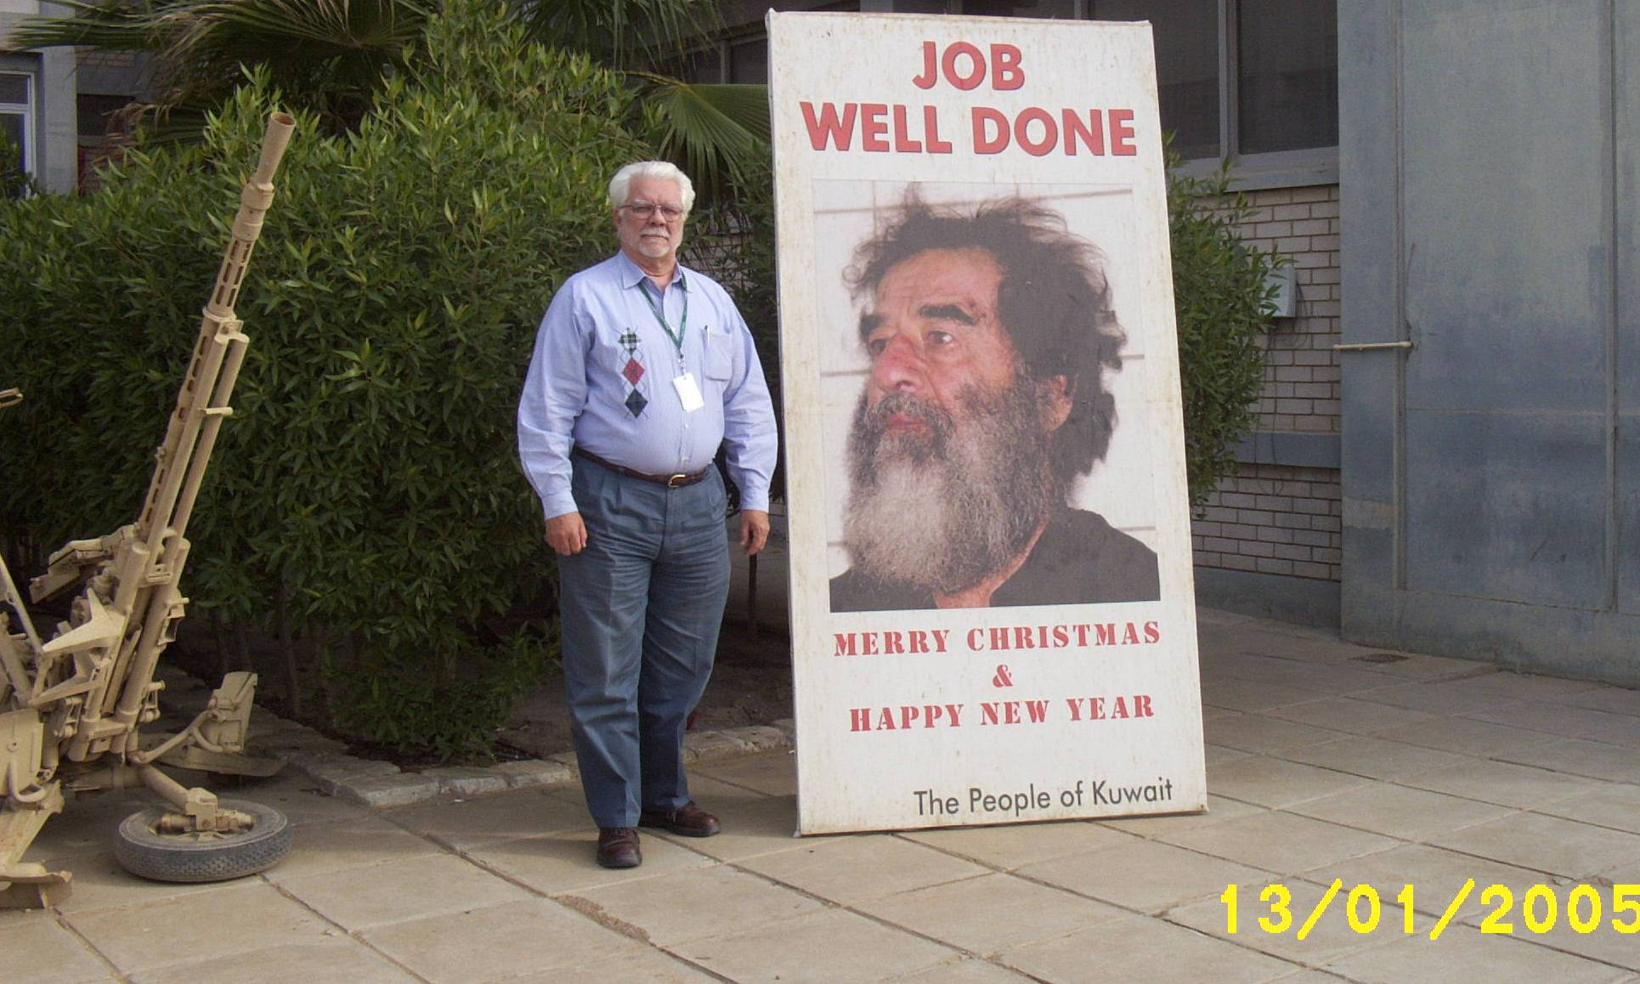
Possum Creek 2002

Rear: The Sonics Tim Monaghan, Dave Herren,
Bob Lennox, Hugh Moore & Truman Futch.

The ‘63 Ladies: Kari Munich, Linda Leonard,
Kathie Wilson, Sharyn Collins, Donna Dawson.

Class of ‘63 down in front: Mel Thompson
What began as friendly get-together years ago has blossomed into an annual event. This September, the Sonics concert is at Clinch Mountain.
When Donna DAWSON Canfield ‘63 got a new job in Flowery Branch, it made the local newspaper. Read all about it.
Baron Scroll Spring 2005 Page 6
After years of TLC, Jimmy COBB ‘63 finally sold his beloved 1957 Chevy. What a day that was.
Don Cooper ‘63 plays duplicate bridge whenever he can. Here he is with friends on Western Night at his favorite Bridge Club.
Greetings from my little buddy. Not sure Santa knows where we are over here, but Rosanne is coming in January and Phil in January or February ....... so life is good. And I will have one more adventure to tell stories about when I get back to the domino tables and smokey ole bars in Texas.
Jim Lockhart ‘62

Donna is also the 1963 class rep.

Send news to her, please!

Hometown manager brings devotion to city
By MATT WEEKS
The Times
Many residents think Flowery Branch is a great place to live, but Donna Canfield's job is to make it better. Canfield, the former owner of Calendar of Events Magazine, was hired in December as the city's new manager of its Better Hometown Program. She replaces Dinah Wayne, who resigned in May.

Donna Canfield, leader of Flowery Branch's Better Hometown program, fell in love with the city years ago.
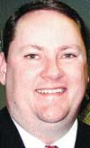
Chris Rainwater, Flowery Branch city manager, is confident in Canfield's ability to do the job.

Canfield said she was convinced she was right for the job, but thought it would take some work to make others see it that way.
"I knew my resume alone wasn't going to get me the job," she said. "I begged them to give me an interview anyway. ... And they finally did."
What didn't appear on paper was Canfield's fervor for the city, something she knew she would have to show town leaders.
It was her magazine that first brought her closer to the town in 1997. She decided to profile the city and walked away with more than a story.
"That's when I really got the fever," she said. "Now to go back and see the potential, it's just been a golden community, it excites me to know that I'm a part of it."
Canfield has been attending meetings and doing her research about the program and the city to bring herself up to speed on happenings in the South Hall town.
"She certainly has her work cut out for her, but she's up to the task," said Chris Rainwater, Flowery Branch's city manager.
"As with any new position I think you have to get your bearing first, then see where you can apply fresh ideas," he said. "And Donna's certainly done that."
The position is part time, but comes with nearly full-time responsibility. Gov. Roy Barnes named the city a Better Hometown in 1999. Along with the title came rigid rules from the Department of Community Affairs.
The Better Hometown manager also is entrusted with making sure the community has an attractive and economically viable downtown and ensuring that historic preservation guidelines are honored, Rainwater said.
Program highlights include the renovation of the Flowery Branch Depot and planting welcome signs and walls near the historic downtown district.
The program is under the same umbrella as Gainesville's Mainstreet program, which Canfield said she would use an example.
"You see what Mainstreet did for Gainesville, the development of their downtown from a ghost town to hub of activity," she said. "I'd sure like to see that happen the same way in Flowery Branch."
Originally published Monday, January 10, 2005
E-mail: mweeks@gainesvilletimes.com





I may kick myself later as I am fully aware of what a beautiful car she is. Can you imagine walking around a race track with that much cash in your pocket. Oh yes, MR. GLOCK (10mm) was also in my pocket. I hope you enjoy the pictures of my SWEET GIRL!
My little beauty was loaded on a car carrier headed for Clearwater, Florida. The gentleman that purchased it is a dealer. He purchased my car to keep for himself. We posed for pictures and he was all smiles. After checking all the 57's out at the speedway I fully understood why he was so happy. I know I am bragging but my 57 was the nicest of them all. One like mine was listed for $32,000.00. It had not sold when I left at 6PM.

September 17, 2004
The Party is over and the car is gone. The photographs were taken this morning as I left for the car show at Lowes Motor Speedway. I had three offers on my 57 Chevy before I could circle the speedway to my assigned parking spot. I sold it within 30 minutes for $18,000.00 cash.

Before the buyer could return with the money I had another guy beg me to take $20,000.00 cash for the car. I kept my word and sold it to the first guy that made, what I thought, was a reasonable offer. I had several buyers look at it and say I was about $4,000.00 low on my price.
Baron Scroll Spring 2005 Page 7
Jim Hengstenberg ’64
For the last three years Jim has been the Executive Director of Sacramento Methodist Assembly, a camp and retreat center for the New Mexico Conference of the United Methodist Church. They have a capacity of 450 persons per night and have just completed the construction of a new 24-room lodge, primarily for folks who no longer want to or are able to "rough it." Summer is their busiest time, when they have 200-400 kids there at all times. They are located 3 hours north of El Paso and 4 hours south of Albuquerque 7,500' elevation in the Sacramento Mountains.

Jim went there because he “was ready to wind down and get out of the Dallas rat race.” His wife Kate is an audiologist who runs a hearing aid practice in Roswell, where she lives during the week before going to the mountains on weekends to join Jim. His main diversions are playing golf, reading and relaxing in their hot tub. They are in a pretty remote location and must travel 45 miles to shop in Alamogordo, the closest town of any size.

The Hengstenbergs have six children. One daughter is a psychologist and presented Jim and Kate with their first grandson in September, and one of their sons is an actor in L.A., who along with his wife are expecting in July. Another daughter is a traveling nurse, currently in San Francisco, and one of the kids lives with Kate in Roswell and works as a pooper-scooper at a ranch that breeds racehorses. One child will be starting law school in September, and one daughter is Roswell has a 2-room bed and breakfast “if anyone in her last year at New Mexico State U, majoring in hotel-restaurant-and tourism.

Jim says he would be glad to host anyone passing through the region, and would even be glad to offer his conference center as a site for a possible future reunion. His house in is heading that way looking for aliens.”

We thank the 1964 classmates for sending news to Anne Marie.

Keep that news coming, please!
Lance Hancock ’64 tells us that he “works, works, works” and cannot envision not working. Lance has six children. His two oldest daughters, ages 31 and 29, are married and have produced one granddaughter. His two middle children, ages 25 and 23, are working. Lance also has two children still in school. His 20 year old son is a junior at James Madison University, and his 16 year old daughter is a junior in high school. “No end in sight for the parenting responsibilities.”

Phil Lockart '64 has been working in Iraq this past year, and about six months ago bumped into a young soldier who had attended Bitburg Middle School. His older brother attended BHS. Unfortunately, Phil does not remember the name, but this just shows how small this world of ours is.
Baron Scroll Spring 2005 Page 8
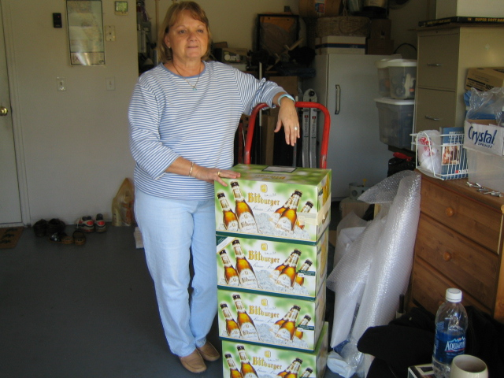
Julie Penrose Vallejos ‘65
It is time again to collect our thoughts and share with our fellow classmates our joys, happiness and sadness. Twenty months has passed since our last reunion and it is hard to believe we are approaching 60. I enjoyed the 2003 reunion and was able to really connect with many of the alumnae. Sharon Stewart and I really did the boogie and man did I feel my age. Regardless, it was a very beautiful moment.

The last two years have been very hard for me. My husband has had three angioplasties, and he will be having his 4th next month. We moved to Mapleton, Illinois in October 2003 and loved the house we bought, 3000 sq. ft. with almost an acre for our backyard. Not only was it roomy, but we also had a lake in the backyard where my grandkids went fishing everyday. Lake Camelot is the name of the development and my aunt and cousin live in the same neighborhood. Almost all our neighbors were retired like us, but there were also some young people with well-behaved kids.

Not long before we started enjoying our retirement I developed Raynaudâs Phenomenon, not to mention my Sciatica that has longed bothered me and was what caused me to retire. Now we are back in California (Patterson). We were gone not even a year and Patterson became one of the most influential towns along Hwy 5, 45 minutes from San Francisco. Three thousand homes were built in the short time we were away. Thank God that we did not sell our home! My greatest pleasure now is seeing my grandkids. I have 8 and 1 more on the way.

I thank Loretta and Anne Marie for picking me as the ‘65 Class Rep.
Sharon WARREN Stewart ’65 always has a great time at the reunions and helps us make them special. Sharon has attended all of the reunions and many of the minis, most recently the trip to Bitburg. March 14-21 Larry Runge ’66 and his wife, Claire, will be visiting Sharon for a mini reunion. (According to Larry, if there is more than one BHS alum in a room it is a mini!) As you can see from the picture, they will be doing some “prosting”. Sharon says anyone in the area is welcome to join them.

A few months ago Sharon was visiting her sister in Palm Bay, FL. One day they were at J.C. Penny’s, and as she rounded a corner almost ran down Sixto Ortiz ’69. Turns out Sixto and his wife, Maria, also live in Palm Bay. By “Larry’s Law” I guess this was another mini!
Pat Hill ’65
His oldest son, Joe, was married on October 16th to Biatrize Beruman in a beautiful church ceremony. Pat’s wife, Mary, is a wedding coordinator for their church, and everything flowed smoothly. Joe and his wife took a four-day cruise to Encinitas and are now sharing their lives in a nice older home in Fresno. Joe works at Valley Children’s Hospital Central California, a major regional children’s hospital, in the ER in admitting and record scanning. Bea, as she likes to be called, works as a dental assistant.

Pat’s daughter, Sarah, will be receiving her Masters Degree in Speech Pathology in the spring of 2005, with wedding plans for 2006. Pat’s wife will finally receive her BA in Special Education in the spring of 2005 with certification to follow. The Hills’ foster daughter, Nickkie, delivered a healthy little girl on September 10th. As for Pat, like the energizer bunny, he just keeps going and going and going - President of our HOA, President of the Central California Chapter for the Knights of Columbus, supporter of Fresno State Softball and still working at the paint store as a buyer and various other duties.
Nancy Robertson Combs ‘65
Nancy is back on line part-time and wants to thank everyone for your prayers, cards and calls. Nancy says “God has truly blessed me this past year with life. Hope all of you had a very merry Christmas and have a happy, happy New Year.”
Send all class news to your rep,
Julie Penrose Vallejos ‘65
Baron Scroll Spring 2005 Page 9
Gail AYERS Morrison '66
When Gail’s family left Bitburg in 1965, they moved to Houston where Gail graduated from high school in 1966. She attended the University of Houston and worked as a sales rep for Sysco, a food service company, for a number of years before transferring to Corpus Christi in 1978. A year later, she changed jobs and sold for a crude oil buyer/fuel distributor until 1987. Gail lost her only child in 1987 when they were involved in a tragic car accident. “After that came the inevitable divorce and a return to school.” Gail spent the next several years completing a graduate degree in Psychology. “It’s true; most people in that field are a bit crazy.” She returned to Houston in 1994, after she remarried, and has worked as a Psychology instructor at Houston Community College since that time. Gail is a "gym rat" and likes most outdoor sports - hiking, biking, skiing, water sports.

We thank this 1966 classmatefor sending news to Anne Marie.

Class rep, Dave Shauer, would like to hear from you 1966 Brats!
Through the years, Gail has often wondered what became of her classmates from Bitburg and felt a pang of envy whenever her non-military friends talked about their high school reunions. She is pleased to be found and is looking forward to the reunion.
Baron Scroll Spring 2005 Page 10

Sorry, folks. No one responded for 1967,
and we’re looking for your Class Rep.

If anyone has a current email address for
Freddy Gonzalez, please let us know.

In the meantime, class news can be submitted
to Anne Marie

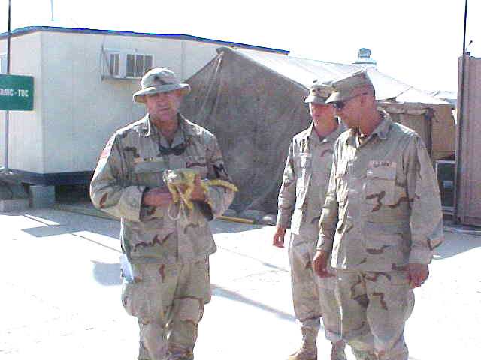
Baron Scroll Spring 2005 Page 11
Mark Wilt ’68

I’ve been blessed with the opportunity to live long enough to apologize for my past behavior to many of the people who have passed through my life.

After Bitburg, I succeeded in failing at several colleges. Eventually I became a pawn of the federal government in several misadventures. During my careening career in the pinball game of life I was able to piss people off at the federal state and local levels of law enforcement. I now look back at a comedy of errors spanning over 32 years. I eventually finished college and received the dubious honor of a commission in the United States Army.

Thanks to Geri LAGISH Hilliard for putting Anne Marie in touch with Mark.

We’d like to hear more from the Class of 1968!
I am on an 18 month extended tour and then retiring from both my civilian job and the army. In the meantime, we patrol the road space throughout Iraq & Kuwait and life is good. Keep us in your hearts.

Another war here and there, including some high adventures in Central America, doing what I seem to do well. Somewhere along the way, I transitioned from the infantry into the military police. (I wanted to spend less time in the field). After 9-11 I volunteered to do some specialized training for federal forces and eventually ended up in Afghanistan to kill bad people. I transitioned to Kuwait, then with the liberation forces into Iraq on or about 19 March 04 and have been bouncing around there since.

After a leave of about six months I returned to this place in September for my final tour. There was a choice of course, but I had a duty and all my fine young kids needed adult guidance, as it were.

The photo is me, (the larger lizard), holding Henry the first back in 2003. He is a “Saliyah”. The green ones have a nasty, venomous, bite but I threatened to nip him in return so we coexisted just fine.
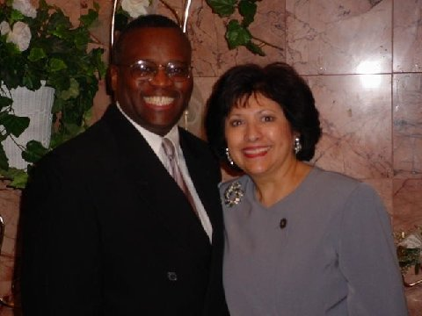
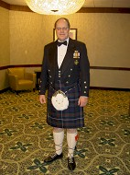
Baron Scroll Spring 2005 Page 12
Mark B. KRONENBERG – Mark has a son who is in the Air Force and stationed at Ramstein. He recently visited his son and family in Germany and went skiing in Garmish.
Kathy KELLY Hill - Kathy and her family recently moved from Ellicott City, Maryland, to Columbia--just across town according to Kathy. She recently completed requirements for a Graduate Certificate in Information and Telecommunications at The Johns Hopkins University. This is in addition to a previously earned master's degree!
Franklin R. "Frank" CALTRIDER– Frank has spent most of his career working in state government in Ohio. Presently, he is Registrar of Motor Vehicles for the state of Ohio, or the head of what is referred to as the Department or Bureau of Motor Vehicles in many other states.
Donald L. WILLIAMS
Don is President of the El Paso, Texas, Family Law Bar Association. He recently presided over and taught a legal seminar on “Family Law and the Military”at Fort Bliss. Don and his wife, Ruth, have been married for 32 years and are pictured here.
Martin “Pud” CHARLTON – Pud and Patty attended the mini-reunion in Bitburg this past October and reported having a great time being back in Bitburg and Spang again. They live in Roswell, Georgia, and are looking forward to the 2006 reunion in Atlanta. Both are working with Bill “Tiny” WIEHL ’67 and Camille Hitch Smith ‘64, to facilitate the festivities.
Jonathan M. Pugh has submitted these updates for the Class of ’69. Jonathan lives in Alexandria, Virginia, where he is a member of the Saint Andrew’s Society of Washington, DC, a Scottish heritage organization. Here he is pictured in his kilt at the recent Robert Burns’ Night dinner, held annually in Washington.

Jon Pugh is
the 1969 Class rep.
Baron Scroll Spring 2005 Page 13
Bruce Gilliard ’70 is still working on his website, so if you stop by remember to do so again as they upgrade and enhance it. Denniel has been doing embroidery work for some time now and they have recently expanded their business to include other types of items to keep them busy into retirement. Their daughter also works in the business and Bruce plans to devote more time once he retires from his position as Assistant. Fire Chief in Pensacola, FL.
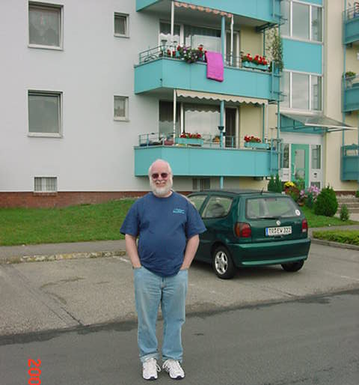
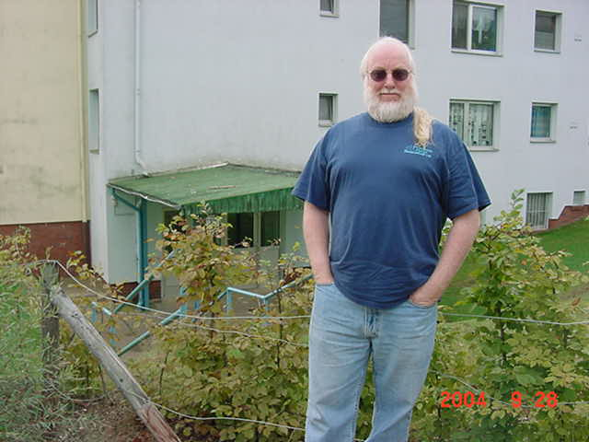
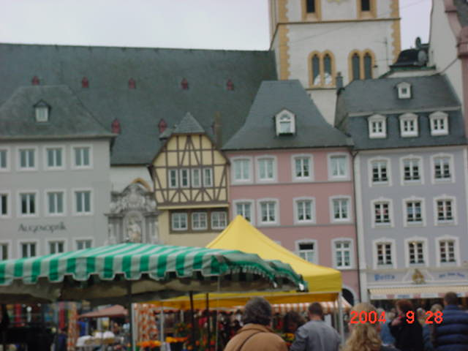
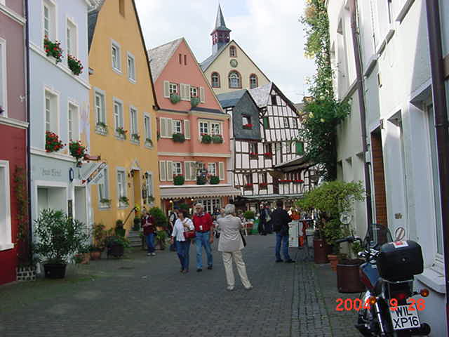
Frank in front of his Ehrant home
Trier Market Place
Bernkastel Street
Naomi OUELLETTE Demolli ‘70 was married and divorced with 4 grown children, when she reconnected with an “old classmate”, Frank Demolli ’70, at our reunion in Kerrville, Texas in 2000. After corresponding and renewing their friendship, they married in 2003 and now reside in New Mexico. Naomi has worked as a Legal Assistant since 1976 and is now enjoying her job with a small law firm in Santa Fe. Frank is an attorney/trial judge for the Pueblo of Pojoaque just north of Santa Fe. Naomi was an avid curler while living in WI, but doesn’t have much opportunity to curl in NM, and Frank is an avid racquetball player. She says the first year of marriage has been terrific but not without adjustments for both of them.

In front of the Trier Housing Teen Club.
They took a 3-week trip to Europe in Sept/Oct of 2004 as a delayed honeymoon. They spent a week at a small hotel in Kyllburg, where Frank lived before moving on base way back when. They also visited Bitburg, Trier, Bernkastle, Kyllburg-Malburg and took a Mosel River cruise. Despite their best efforts, they were unable to get onto the housing area but did drive around the old base. Many of the buildings were identifiable, although they have different uses now. They also visited what used to be the housing at Ehrang (outside Trier), since Frank had also lived there for a short while. Those buildings are now condos and other buildings have been added in between the six original housing units. It was a wonderful trip down memory lane!

Naomi is the 1970 Class rep.
Page 13 continued

Bruce Gilliard ’70 is still working on his website, so if you stop by remember to do so again as they upgrade and enhance it. Denniel has been doing embroidery work for some time now and they have recently expanded their business to include other types of items to keep them busy into retirement. Their daughter also works in the business and Bruce plans to devote more time once he retires from his position as Assistant. Fire Chief in Pensacola, FL.

After a 10-hour flight from Phoenix on Thursday to London’s Heathrow airport, the flight to Frankfurt was delayed for a couple of hours. Finally, arriving at Frankfurt airport and grabbing our bags, we entered the double glass doors to the outside world to be met by Claire and Larry Runge. Actually, they were waiting for Janet and Jerry Rodgers, who were to arrive on the same plane as us, but hadn’t made the connection in Heathrow. Poor Janet and Jerry had been stuck on the plane in San Francisco for over 5 hours as the airline tried to fix the plane. But that’s another story in itself.

After numerous hugs and hellos, Larry and Claire went on to Bitburg while we spent the night in Frankfurt at a nearby hotel. We left a message for Janet and Jerry to call us at the hotel when they arrived in Frankfurt so we could take them up to Bitburg since the Runges were leaving after having been at the airport all day.

Now we were ready to continue our big adventure into our past. First thing we had to do is find the rental car counter. This took over an hour. Finding the rental car was easy since we had discovered the car way before we found the counter. Once we were in the car, all we had to do was figure out how to change the GPS system to English speaking, input a Germany address and remember how to drive a stick shift. No problem, except the address we had for the hotel wasn’t accepted by the GPS system. Knowing where we wanted to go, but having no idea how to get there, we were off, out of the airport complex and lost. Of course, it was dark by now, and we were still getting accustomed to International road signs. Who has the right away on the circles in Germany, anyway? After about 15 kilometers, we stopped and tried to get directions. Oh yah, that worked out just great. We discovered we were on the right road but the hotel we were looking for was 20 kilometers in the other direction. By now we were getting pretty testy, and my copilot/navigator is telling me to take her back to the airport and she will take a taxi to the hotel. We finally found an airport hotel. Of course it wasn’t the one we were booked into, but we did commission a taxi that we followed to our hotel. Finally, we reached the hotel at about 9:00 pm, after more than 3 hours in Germany. The next day we discovered we were about 1 mile from the airport, who knew?

When Janet and Jerry arrived at Heathrow were paged and asked if they knew a “Tiny” and were given our message. When they arrived at Frankfurt, they called us at the hotel. Luckily, we weren’t going to have to venture back to the airport to pick them up, because the hotel had a shuttle. Everyone was tired; we called it a night and met them in the morning for breakfast.

After breakfast Jerry and I cranked up the old GPS and drove on to Bitburg. The brewery had setup 3 separate hotels for the alumni, all within a couple of blocks of each other, the Simonbrau, the Eifelbrau and the Louis Muller. We deposited Janet and Jerry at the Eifelbrau, and we checked into the Louis Muller. We all met Larry and Claire at the Simonbrau for lunch.

Bitburg has changed a lot since our high school days, yet it is almost the same. After lunch and a few beers, we wandered down to the old train station, which is no longer used, except as a café. On the way back, a stranger drove up to this wandering group wanting directions. Turns out the stranger was no stranger at all, but Tony Alves, just in from driving around Europe looking for his old banking haunts, and I assume accounts, but that is another story in itself.

At Larry’s suggestion, we all met that evening to caravan to a restaurant with the best butter schnitzel you have ever tasted, only to find it closed. We eventually ended up in Dutteldorf at another restaurant for a fine meal and a lot of story telling. As the week went on, more alumni arrived and the story telling was repeated for the new arrivals. Funny how the stories got better with each new version.

The next day was Sunday and the town was having a street fair called the Farmer’s market. This was our first chance to scout out ATM locations and practice how to extract cash from a German ATM. We also had our first experience, since high school, buying a brat from a street vendor. They are not as prevalent as they were 30+ years ago. We also discovered that many of the streets that we drove on in town were now pedestrian walkways, with no cars allowed. Hauptstrasse that you would take through town over the hill past the church, Rat house and Luigi’s to the Eifelbrau intersection is now a pedestrian mall.

On Monday, Joy and I went into Luxemburg to pick up Kelly Flynn and Suzy Wayne who had just flown in from New York via Amsterdam. Thank goodness they flew into Luxemburg instead of Frankfurt. Not only was it closer to Bitburg, but also we were able to park about half a block from the terminal. Real simple. Of course on the way back we traded our traveling stories.

By the time we had returned to Bitburg, and got Suzy and Kelly situated in the hotel the bar at the Simonbrau had filled up. When we walked to the Simonbrau from the Louis Muller the new arrivals including, Lyn and Jim Slaughter, Rosemari Garrison Davis and her husband Bill, Sharon Warren and her husband Rich. So another round of story telling began and numerous beers were consumed. I really think the Simonbrau’s revenue shot up during our visit.

On Tuesday, we caravanned down to the Rudesheim for a boat cruise along the Rhine River. Since we missed the boat, we had some time to tour the old town before the next boat docked for passengers. When the river-cruising group returned to the scene of the previous night’s gathering, we found Bob Daniels and his wife Bev enjoying a cold Bitburger Pils. Shortly after that, Cam and Irish Strong, who had just arrived from a weeklong trip to Italy, joined us. Cindy Rush and Pat Schreiber had accompanied Cam and Irish to Italy, and Cindy was also at the Simonbrau. Unfortunately, Pat had fallen seriously ill during the Italy trip and Cam and Irish checked her into the city’s hospital shortly after they arrived in Bitburg. But that’s another story in itself. Suffice it to say that Pat finally made it home, and she is almost fully recovered.

On Wednesday, we took the train into Trier for shopping. (By the way, the Bitburg train station is now at Erdorf.) Once at Trier we seemed to break up into teams and were going to rendezvous back at the Porta Negra that afternoon. While shopping, Patty and Pud Charlton joined us. They had just come in from their own European excursion.

On Thursday, we caravanned to Bernkastle for lunch and additional shopping. Bernkastle has not changed much at all and is as quaint as always. I think we hit the shops more there than we did in Trier. Some of us cut the shopping short to go to the castle on the hill and the nearby winery. That evening we had a great dinner, as a group, at the Eifelbrau. Another great day.

Friday morning, we drove over to Spang and Larry helped us get base passes. We took the opportunity to cruise the base, and later some of us drove through Spang and Dahlem to check out what had changed. Since we had passes, we also took the opportunity to check out what had changed at Bitburg AFB. What was the old French Concern is now operations for the wing. The high school has moved from the old site to a new location closer to the exchange. The old school site is now the middle school and elementary school. We had to check out the old buildings and gym. As it happened, the school was conducting an assembly with the base Commander as guest speaker. Of course, our presence caused a little commotion, and when we explained who we were, the Commander took some time to introduce us to the students. You should have seen their faces. Here we were alumni from their school from 30 years ago. I think we were probably older than the Base Commander. After the assembly, a lot of the students came up to us and wanted to know where we lived now and what school was like back then.

That evening, the high school held a pep rally and paraded through the housing area. They included us in their parade that I am sure, aside from amazing the students, really amazed their parents and other bystanders along the parade route.

Saturday was our first rainy day, and of course, the Homecoming football game. Many of us didn’t last the whole game due to the rain, but those of us who did were introduced at half time to rousing applause and recognition. The Barons soundly beat Mannheim, which put them in the playoffs. That evening, we had our last dinner at the Simonbrau. Dr. Dietzsch joined us at the dinner and presented the group with some memorabilia from the brewery and some insights into the current Anglo/German relations. We also had a chance to present to Dr. Dietzsch the gift we had purchased for him in recognition for all his assistance and support of our alumni group. Of course, there is a story about the gift traveling through Europe with Tony. Since Tony had brought the gift over from the States and had toured Europe before arriving in Bitburg, he had to explain the gift at each border crossing and talk he way out of paying customs each time.

After dropping Suzy and Kelly at Luxemburg, Joy and I were off to meet up with several couples for one last hoorah at a Holiday Inn in Frankfurt. Finding our way to the hotel and then caravanning back to the airport to turn in the cars and catching the shuttle back to the hotel is a story in itself.

Needless to say, it was a great trip with great people. Check out some of the photos that Jerry has posted on the Bitburg web site http://home1.gte.net/jasenr/index6.htm. They tell a story in themselves and I strongly suggest that when you meet any of the aforementioned folks, sit down and have a beer over a story or two, there are a million of them. I can’t wait until we go again. Larry, are you planning the next trip yet? Great job!

Baron Scroll Spring 2005 Page 15
“Brats: Our Journey Home”
“An Intimate Portrait of a Lost American Tribe “

Did you know there is a feature-length documentary being made on brats? The film features music and narration by Kris Kristofferson and is based on interviews with more than 500 brats, some famous such as General Norman Schwarzkopf, but mostly the not so famous like you and me. Brats’ writer/director/producer is Donna Musil, an independent filmmaker and fellow brat, who has been working on this film for five years.

Although they have finished production of the film and are at the end of the editing process, there are still many costs facing them. If you have an interest in making a donation you can go to their website for more information. Brats Productions is also still looking for home movie footage and still photographs from military families for use in further productions. They are also still accepting questionnaires from brats interested in contributing their thoughts for future projects. I am sure there are many of you who have inherited home movies and pictures that you could share.

For more information on the film and/or contributions or participation, please go to the Brats Our Journey Home website.

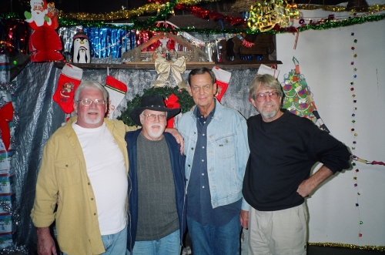
The Sonics Clinch Mountain Concert
Baron Scroll Spring 2005 Page 16
Between 1962 and 1964 “The Sonics” were a group of 5 GI’s stationed at Bitburg and Spangdahlem and entertained many of us at the teen clubs and the 1962 Bitburg Junior Senior Prom. They also performed throughout Germany and France at Rod & Gun Clubs, Officer’s Clubs and NCO Clubs, as well as civilian venues. “The Sonics” were also the opening act for many of the USO entertainers such as Sam Cooke.

The “troops” are gathering once again at Jimmie Carroll’s farm for a reunion and a Sonics concert, at the Outdoor Pavilion in the shadow of Clinch Mountain. Bitburg and Spangdahlem GI’s, Bitburg High School Alumni, families & friends, Sonics Groupies, neighbors, and anyone else who wants to experience a great time is invited to attend a reunion and concert to be held September 23, 24 & 25, 2005 on the banks of Possum Creek. If you haven’t been to one of the BHS reunions yet, this is a great opportunity to “get your feet wet”, especially if you live in the area. If you would like more information contact Donna Dawson Canfield ’63 or leave a message on our message board. Driving directions can be found on our web page.

Possum Creek is the historic site where the original 5 members of “The Sonics”, International Rock and Roll Twist Combo, recording stars of “Studio Records”, assembled in October 2001, and performed together for the first time in nearly 40 years. This will be the fifth get together of the entire group. There will be additional musicians and entertainers coming from all over the country to join the “60’s Rock and Rollers” on stage to add to the entertainment. Weather permitting; there will be an outdoor cookout and other outdoor activities.

Everyone is welcome! Make your reservations now at one of the many hotels in nearby Kingsport, Tennessee. It is not a race weekend at nearby Bristol, so there should be an abundance of accommodations available.

The local airport is the Tri-Cities Municipal Airport. Also, the Knoxville Airport is a short 95-mile drive on the Interstate. Be sure to bring any memorabilia, wives/girlfriends, husbands/boyfriends, photos, cameras, both video and still, and get ready for a great time. It might help to bring what you want to drink as well, and if you are driving, bring lawn chairs.

Jimmie, the “Mayor” of Possum Creek and original band Roadie, is a superb host and has a beautiful setting for this event. As usual, brother Donny, Stage Manager Extraordinaire, will be preparing the stage and the grounds to accommodate the crowd in style.

For the last few years there have been more than 45 people in attendance at any one time, and many of them have already made plans for this year’s return visit. No advance reservations are required at “The Creek” or for the concert. JUST SHOW UP! !

Once again there will be a gift exchange and we are asking that every person bring an UNWRAPPED gift under $10.00 in value.
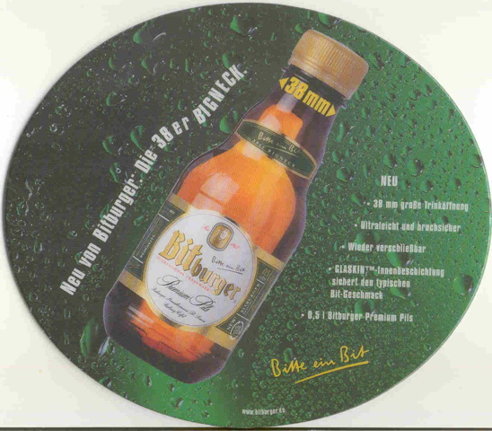
Baron Scroll Spring 2005 Page 17
Collectible mouse pad
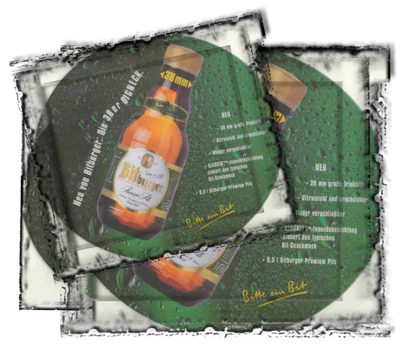
The note below from Michael Dietzsch was sent to Cam ’66 and Irish ‘67 Strong. The Remington statue Dr. Dietzsch refers to was given to him after our 1987 Vail Reunion, as a token of our appreciation for everything he did to help us have a very successful reunion. Over the years Bitburger Pils has provided us with beer and t-shirts to be given away at our reunions and continues to provide us with beer. They also assist us in obtaining Bitburger Pils items to be sold at the reunions.

“I wish you and your family a merry Christmas and a happy and healthy New Year. I am very thankful for the photographs, which were sent to me - so I can use them for the English-speaking Eifelpost newspaper.

They also remind me of the charming meeting with the Alumni Association in Bitburg and the most wonderful gift of the Frederic Remington statue. Recently, I saw a photo of the Oval Office in the newspaper with the President of the United States and the "Bronco Buster" statue on a sideboard. I am very proud of this symbol of friendship.

Meanwhile my second daughter has also married and moved to Chicago where they will live for the next three years.”

